LoRaWAN TEMPERATURE AND HUMIDITY SENSOR NODE
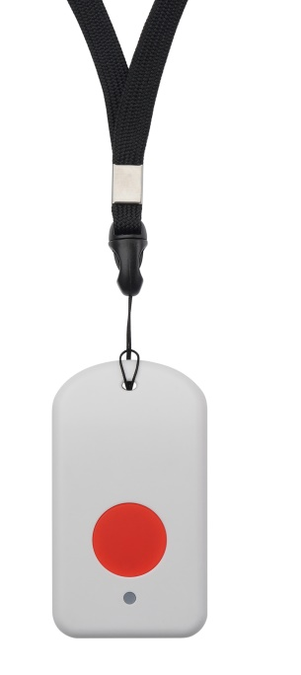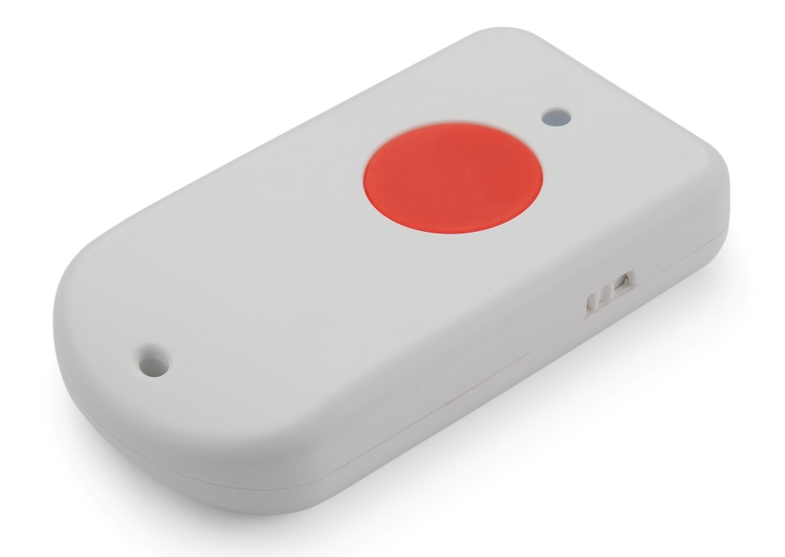
Description
The Dragino LoRaWAN GPS Tracker LGT-92 is an open source GPS tracker base on Ultra Low Power STM32L072 MCU and SX1276/1278 LoRa Module.

LGT-92 includes a low power GPS module L70 and 9-axis accelerometer for motion and attitude detection. The power for both of the GPS module and accelerometer can be controlled by MCU to achieve the best energy profile for different applications.

The LoRa wireless technology used in LGT-92 allows the user to send data and reach extremely long ranges at low data-rates. It provides ultra-long range spread spectrum communication and high interference immunity whilst minimizing current consumption. It targets professional tracking service.

LGT-92 series products include two major variants:

LGT-92-LI: is powered by 1000mA rechargeable Li-on battery and charge circuit, which target for real time tracking with short tracking uplink.

LGT-92 is an open source product, it is based on the STM32Cube HAL drivers and lots of libraries can be found in ST site for rapid development.
Features
- LoRaWAN 1.0.3 compliant
- Regular/ Real-time GPS tracking
- Built-in 9 axis accelerometer
- Motion sensing capability
- Power Monitoring
- Charging clip with USB port (for LGT-92-LI)
- 1000mA Li-on Battery power (for LGT-92-LI)
- Tri-color LED, Alarm button
- Bands: EU868
- AT Commands to change parameters

Specification
System
- MCU: STM32L072CZT6
- Flash:192KB
- RAM:20KB
- EEPROM:6KB
GPS,L70R
- Acquisition: 16mA
- Tracking: 13mA
- Cold Start: <35s
- 8uA@Backup Mode
- Warm Start: <30s
- Accuracy: < 2.5m CEP
- ReHot Start: <1s
Accelerometer
- MPU9250 9-axis
- triple-axis MEMS gyroscope
- triple-axis MEMS accelerometer
- triple-axis MEMS magnetometer
- 3.5mA operating current
Power Consumption
- Sleeping Mode: 77uA (for LGT-92-LI), 3uA (for LGT-92-AA)
- Tracking: max: 38mA
- LoRa Transmit: 24 ~ 150mA

